Firmware Update Guide
For Solid State Drives (SSDs)

Document History

Revision | Release Date | Purpose and/or Desc. Of Changes
3.0 | June 29, 2009 | Third

CAUTION: Please backup data from your SSD before start update F/W. Super Talent is not held responsible for lost data. To ensure SSD data is safe, please backup all data on a separate drive before proceeding to update F/W on your SSD.

This update tool can be only used to that SSD the capacity is less than 256GB MLC and 128GB SLC. If the capacity is 256GB (MLC) or 128GB SLC, don’t use this tool.

- Note: In order to update F/W, please ensure that F/W and SSD model must match accordingly. This tool is used only for the following SSD models: FTDxxGL25H, FTMxxGL25H, FUDxxGL18M, and FUMxxGL18M.
- Limitation: This tool only works with SATA port configured to “Legacy/Compatility” mode or “Enhanced IDE” mode. “AHCI” mode is not supported.

F/W update via Booting Diskette

Firmware Files
- Please download FWUPD.rar from the Super Talent website.

- Unzip FWUPD.rar to see the two files inside. The two files are:
    - SATAISP.exe
    - ISPB.LIB

Make a Booting Floppy Diskette
- Windows 98 is recommended

F/W Update Process

- Copy the two unzipped files onto the floppy diskette

- Insert the floppy diskette into the floppy drive

- Connect the SSD with the SATA cable and SATA power cable

- Turn on the computer. Check the BIOS settings to make sure that the floppy diskette boots up

- Type “SATAISP” to run the F/W update tool

- If the SSD is connected correctly, the message in Figure 1 will appear.

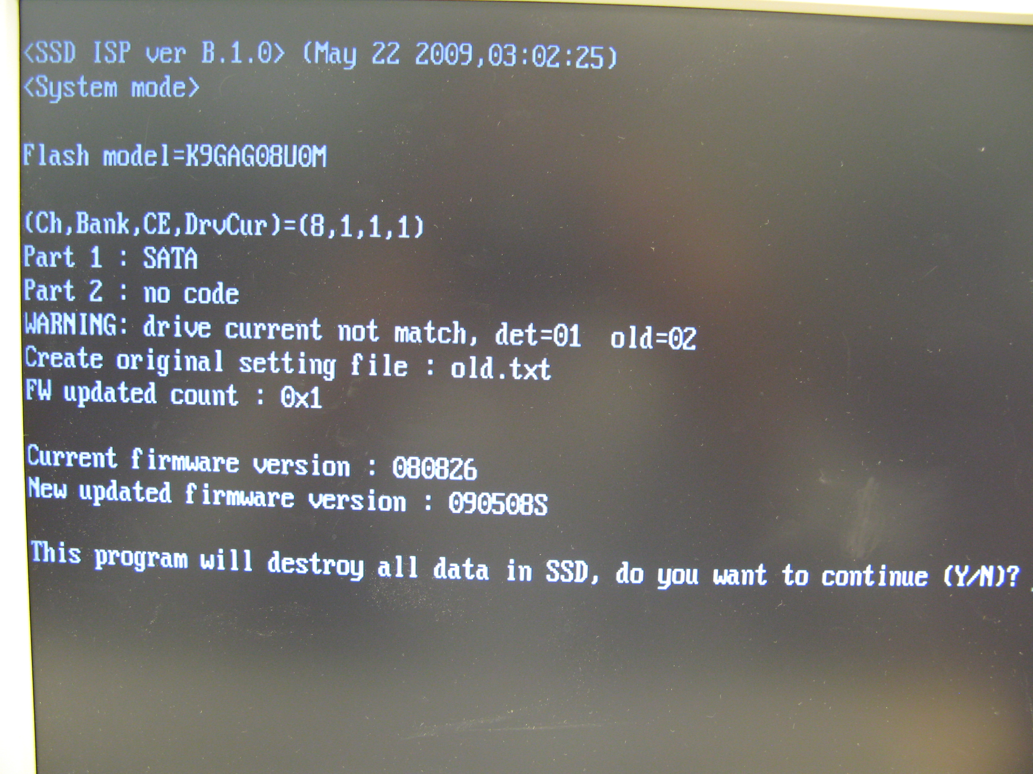
Figure 1: Update tool detects the SSD information

- Press “Y” (if you already backup data or you don’t need)

- The system will automatically update the F/W and format the SSD. Figure 2 is a screen capture of a successful F/W update. The result will be saved to a file named “mo.txt”.

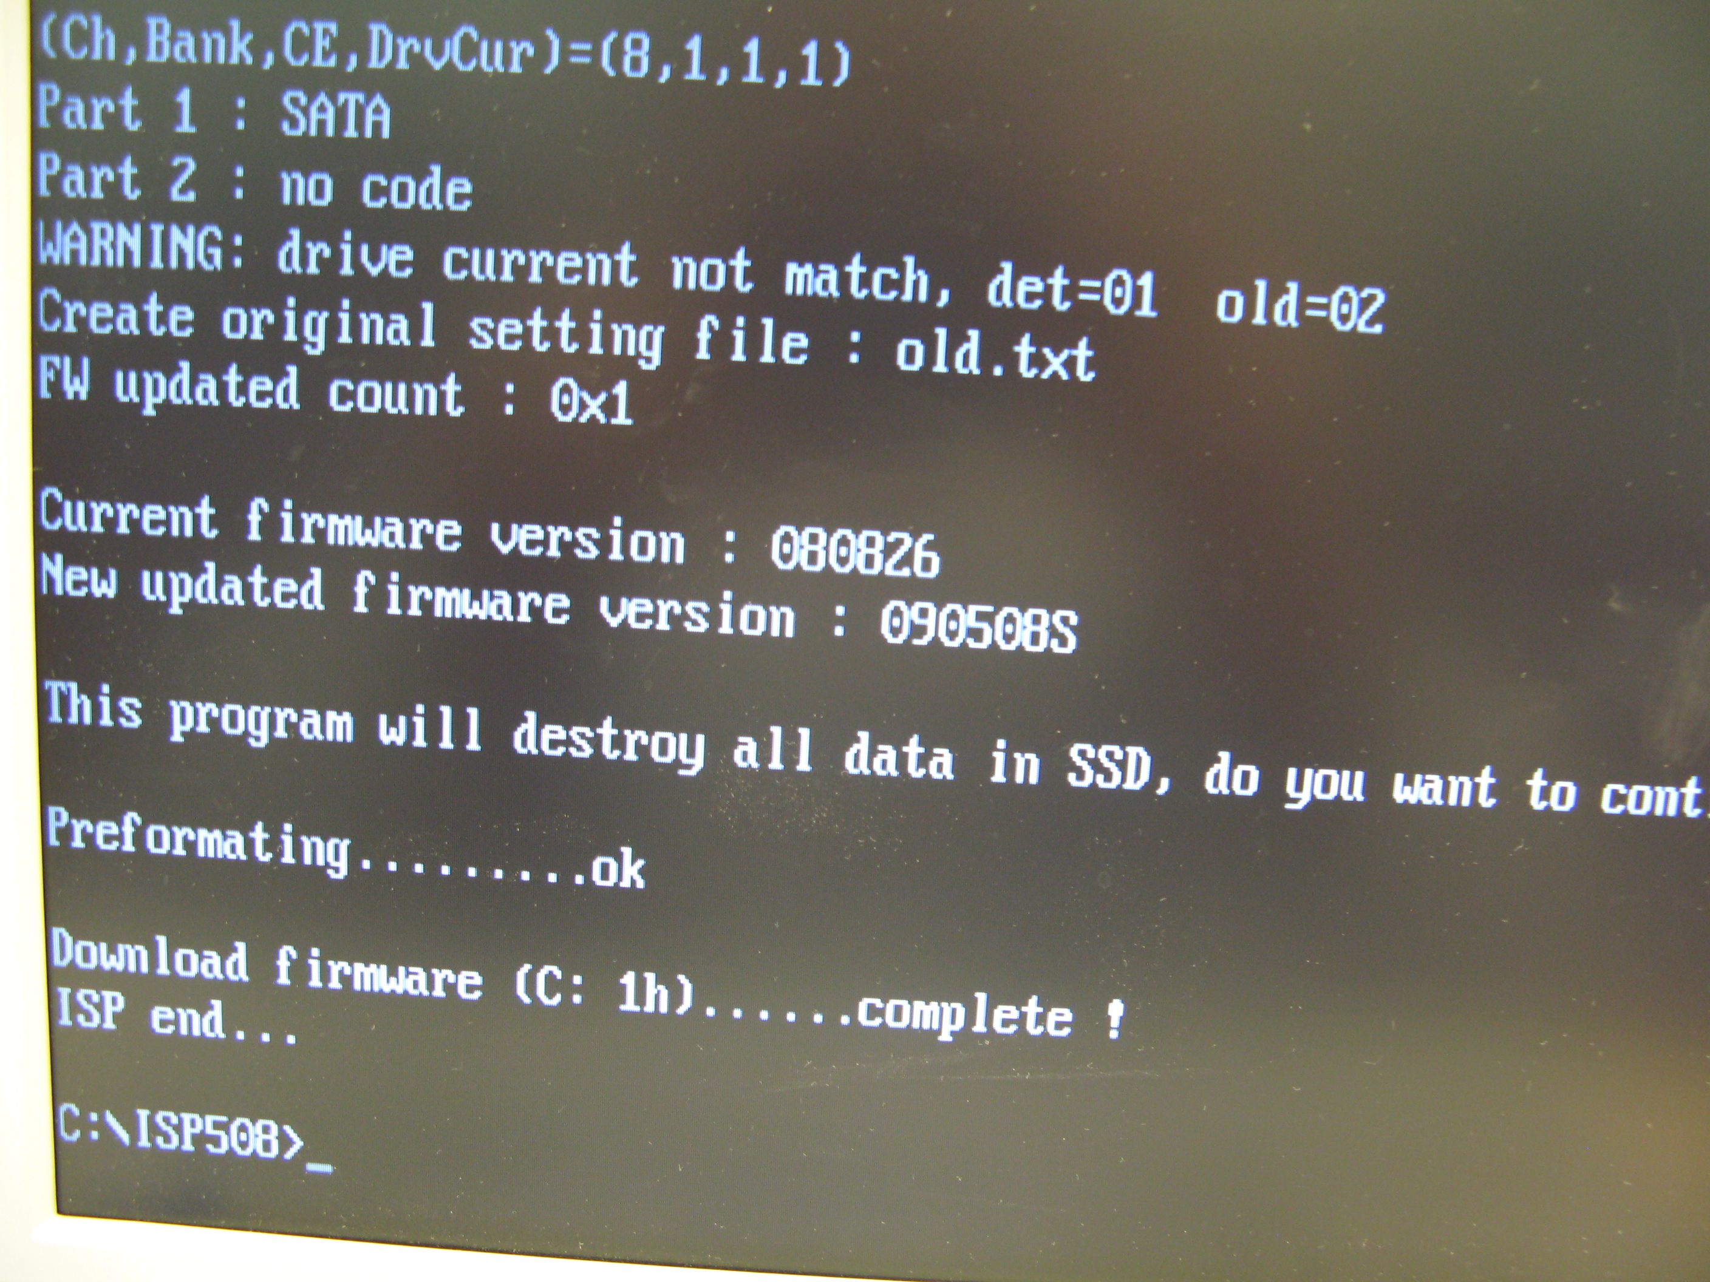

Figure 2: Screen Shot of Successful F/W Update
- Firmware version will change to 090508 after update.

Firmware Update via Bootable USB Drive

Firmware Files
- Please download FWUPD.rar from the Super Talent website.

- Unzip FWUPD.rar to see the two files inside. The two files are:
    - SATAISP.exe
    - ISPB.LIB

Check CMOS Setting
- Select the bootable USB drive as the first boot device

- In order to update the F/W, the following BIOS settings must be set:
    - Integrated Peripherals
    - PCI IDE BusMaster: (Enabled) Select
    - On chip SATA Type: (Native IDE) Select
    - Options: Native IDE / RAID / Legacy IDE (don’t select AHCI)

- Save Changes

F/W Update Process
- Copy the two unzipped files onto the bootable USB drive

- Plug the USB drive into the USB connection into the computer

- Connect the SSD with the SATA cable and SATA power cable

- Turn on the computer and enter the correct CMOS settings (listed in above paragraph)

- Boot to USB drive

- Type “SATAISP” to run the F/W update tool

- If the SSD is connected correctly, the message in Figure 1 will appear

- Press “Y” (if you already backup data or you don’t need)

- The system will automatically update the F/W and format the SSD. Figure 2 is a screen capture of a successful F/W update.

- Firmware version will change to 090508 after update.

